SPRINT1 TEST CYCLE (EPIC1 )

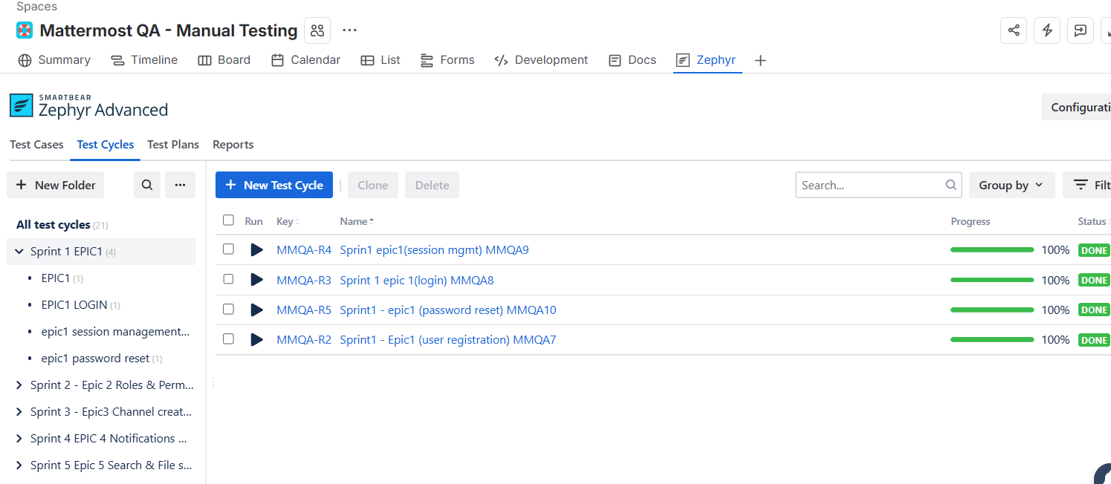

SPRINT2 TEST SYCLE (EPIC 2)

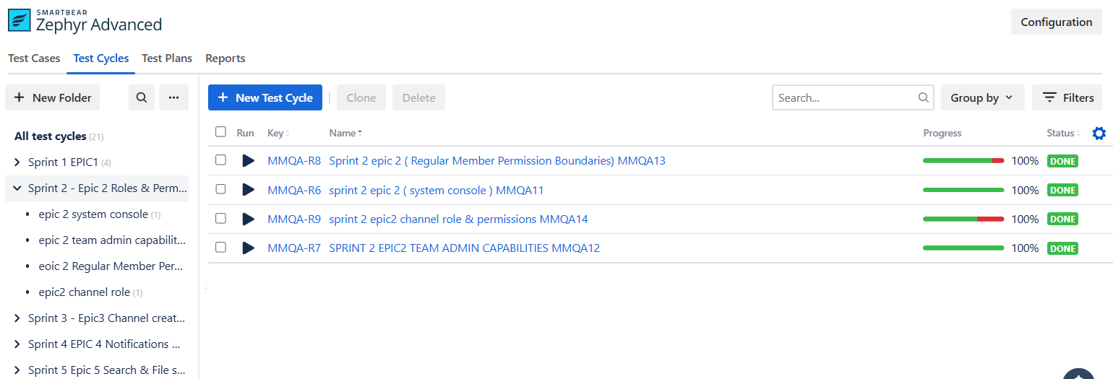

SPRINT 3 TEST CYCLE ( EPIC 3 )

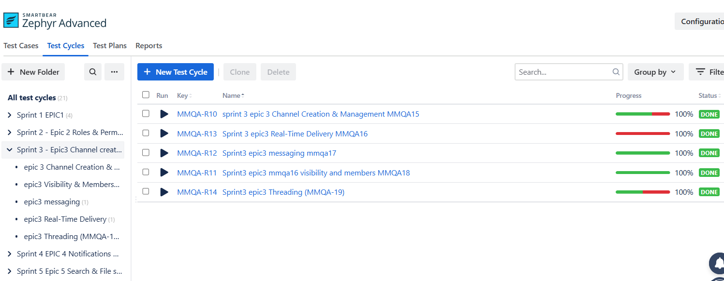

SPRINT 4 TEST CYCLE ( EPIC 4 )

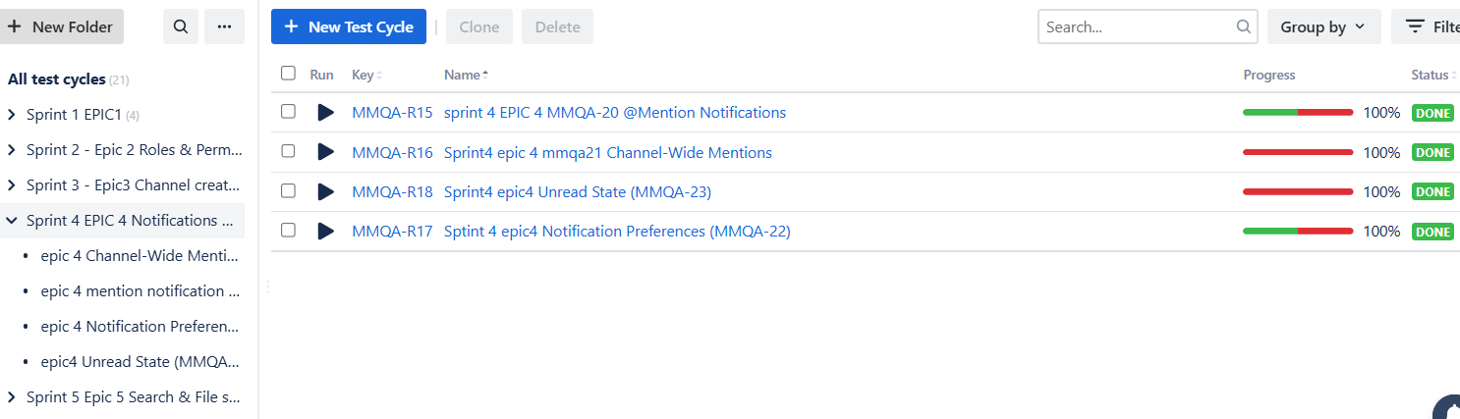

SPRINT 5 TEST CYCLE EPIC 5



